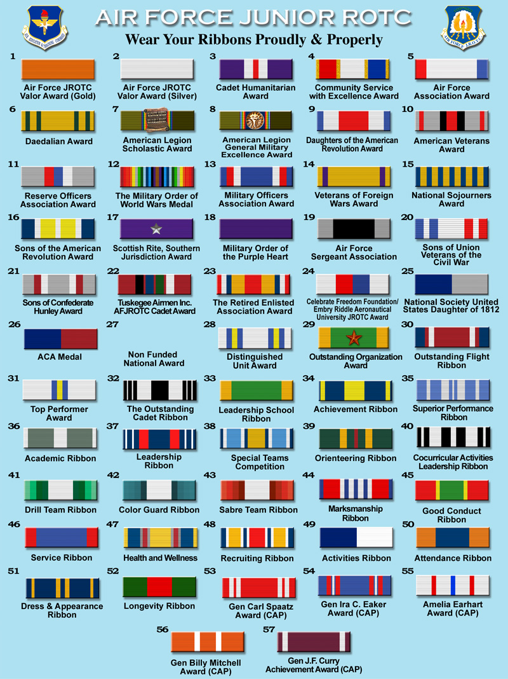

Cadet Enlisted and Officer Ranks (all branches)

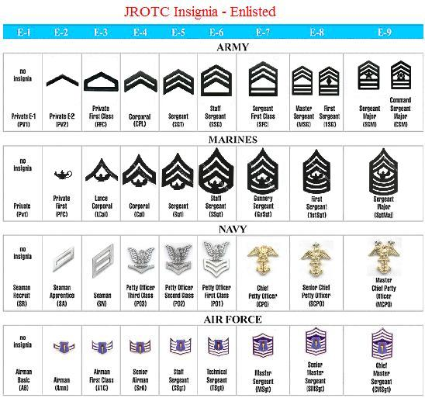

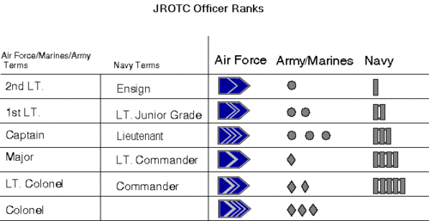

**AFJROTC Unarmed Inspection Team Packet**

When answering a question a Cadet will always start or end a response with Sir or Ma'am and restate the question being asked. If a Cadet could not restate the question, simply respond with the answer and an appropriate Sir/Ma'am. If a Cadet does not know the answer to a question that Cadet will say "Sir/Ma'am this Cadet does not know!"

1. When did the first sustained, heavier than air, man powered flight take place?  
17th of December 1903

2. Where did the first sustained, heavier than air, man powered flight take place?  
Kitty Hawk, North Carolina

3. Who was at the controls of the first sustained, heavier than air, man powered flight to take place?  
Orville Wright

4. When was the first JROTC unit activated?  
1911

5. Where was the first JROTC unit activated?  
Cheyenne, Wyoming

6. When were the first 20 AFJROTC units activated?  
1966

7. When were females issued uniforms and counted for enrollment in JROTC?  
1973

8. When did the Air Force become a separate branch of the military equal to the Army, Navy, and Marine Corps?  
18th of September 1947

9. Who wrote the National Anthem?  
Francis Scott Key

10. Who is the "Father of the Air Force"?  
General Billy Mitchell

11. Who is the Commander and Chief of the Armed Forces of the United States of America?  
President Barrack Hussein Obama

12. Who is the Chairman of the Joint Chief of Staff?  
General Martin E Dempsey

13. Who is the current Air Force Chief of Staff?  
General Mark A. Welsh III

14. Who is the Chief Master Sergeant of the Air Force?  
James Cody

15. Who is the Secretary of the Air Force?  
Eric Fanning

16. Who is the Secretary of Defense?  
Chuck Hagel

17. Who is the Secretary of State?  
John Kerry

18. Who is the director of AFJROTC?  
Colonel Cameron L. Gilbert

19. Who is your SASI?  
(N/A)

20. Who is your ASI?  
Master Sergeant Mark Reed and Master Sergeant Joseph Ramirez

21. Who is the Superintendent of your school?  
Mr. Charles Earling

22. How many branches of the armed forces are there in the U.S.?  
Five (5)

23. Name the branches of the U. S. Armed Forces.  
Air Force, Navy, Army, Marine Corps. and Coast Guard

24. What are the Air Force core values?  
Integrity first, Service before self, and Excellence in all we do.

25. What are the four forces of flight?  
Lift, thrust, drag and weight or gravity.

26. What is the mission of the Air Force?  
To fly fight and win in air, space, and cyber space.

27. What is the mission of AFJROTC?  
To develop citizens of character dedicated to serving their nation and community.

28. What is the mission of the NJ 20003rd?  
The mission of the NJ 20003rd cadet core is to strengthen character and integrity, instill personal responsibility and self discipline, develop leadership skills, promote community service, understand and appreciate the role of the military in society, learn the major elements of aerospace, and build informed, and productive citizens who will become the next generation of leaders and managers in our community.

29. What is the mission of Williamstown High School?  
To provide students with an atmosphere where they can become responsible, productive citizens and lifelong learners.

30. What do the colors on the United States flag symbolize?  
Red symbolizes hardiness and valor  
White symbolizes purity and innocence  
Blue symbolizes justice, perseverance and vigilance

31. What are the five colors of a military map?  
The five colors of a military map are: black, blue, green, brown and red.

BLACK-indicates cultural or man-made features such as buildings, roads, surveyed spot elevations and all labels.

BLUE-identifies hydrography or water features such as lakes, swamps, rivers and drainage.

GREEN-identifies vegetation with military significance such as woods, orchards and vineyards.

BROWN-identifies all relief features and elevation such as contours on older edition maps and cultivated land on red-light readable maps.

RED-classifies cultural features such as populated areas, main roads, and boundaries on older maps.

32. What rank are you?  
Sir this cadet’s rank is Cadet ______

33. What are your ribbons in order?

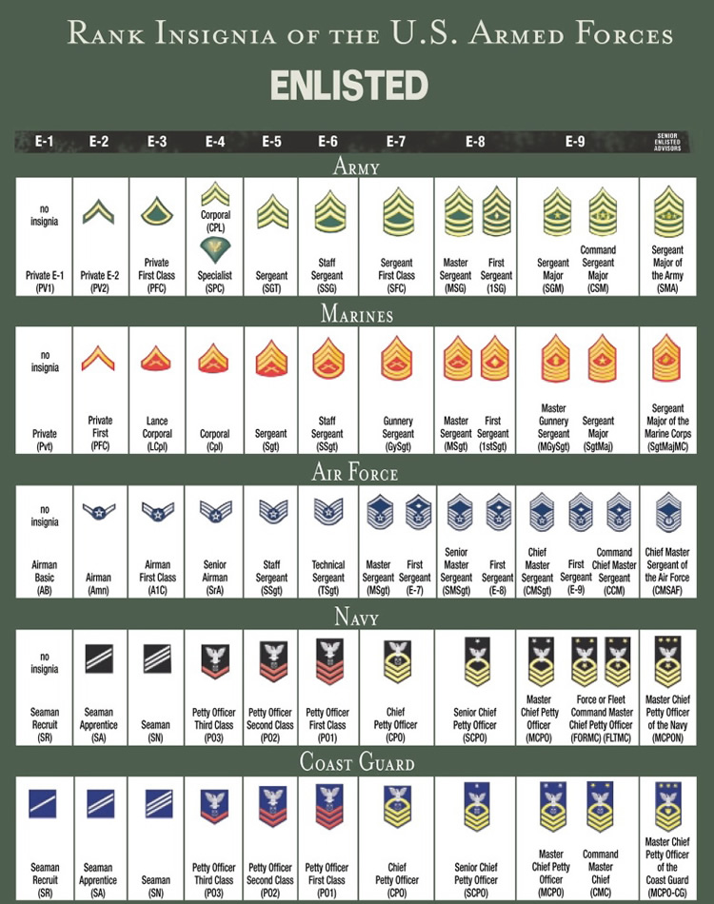Enlisted Ranks All Branches

Officer Ranks All Branches

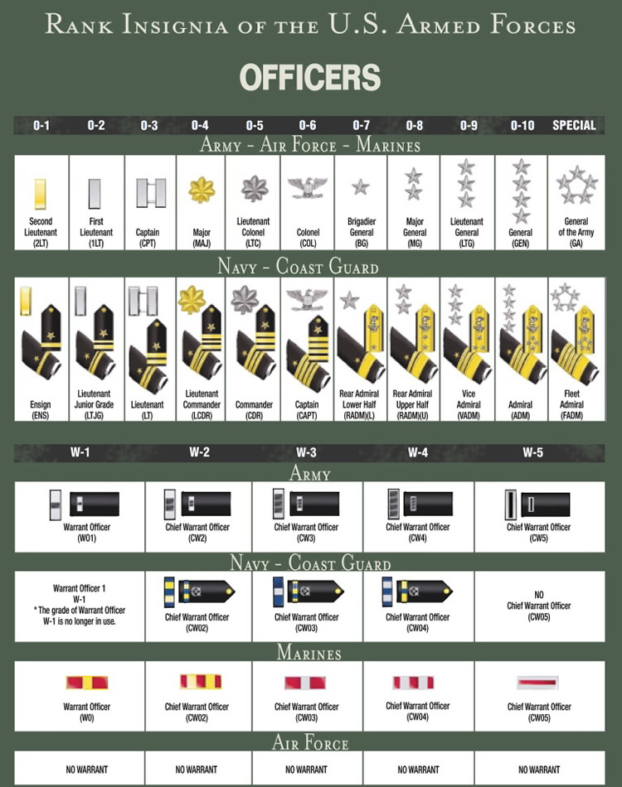

***Cadet Verbal Responses***

Inspection will include questions asked to determine a cadet’s poise, confidence, and overall military/government/historical knowledge, along with specific questions about their service branch. Examples of possible questions include the following:

**Basic Level-(Every cadet should know all of these)**

* Names or present and very recent past Presidents and Vice-Presidents.
* Questions about any ribbons, medals, etc. found on the cadet’s uniform.
* The cadets School Name, School Nickname, or other school related items.
* Home-state capital, Nations Capital, or common-knowledge and current events.

**Mid Level-(Many cadets should know many of these)**

* The Governor of the cadet’s state, Senators, Sec. of Defense, State, or Interior.
* Meanings of common military abbreviations, Chain-of-Command questions.
* Questions about drill movements and their correct execution.
* Questions particular to your Service Branch, Service Commandant.
* Dates and significance of Memorial Day, Independence Dat, WWI or WWII.

**Advanced Level-(Few cadets are expected to know many of these)**

* Other more obscure governmental and historical questions.
* Detailed questions concerning famous battles and international conflicts.
* Advanced inner-service questions, cadets JROTC service history.
* Extensive Chain-of-Command.
* Major Service training posts, famous military figures.

**Important Note:**

*Judges may ask questions during inspection they do not expect the cadet to answer correctly, if at all. Do not allow your cadets to become flustered by this line of questioning, thus losing their military bearing! If a cadet doesn’t know the answer to any question posed to him/her, a strong,”This cadet does not know sir/ma’am!” will be the best response possible.*

*While it is rare, a judge may incorrectly apply a regulation from their service to that of your team’s service branch. If you feel a rule has been incorrectly applied to your unit,* **DON’T BELABOR THE POINT WITH THE JUDGE!** *If the judge presses a point a cadet feels is incorrect, the correct response should be “Sir/Ma’am this cadet has been instructed that _____ is correct”. Don’t lose military bearing!*

*Should this occur,* **IMMEDIATELY** *after completing the inspection process, inform your commander and then reach the Head Judge and discuss the incident. They will then contact the judges and make a ruling, thereby assuring the score sheets reflect the correct rule interpretation and scoring.*