**Chapter 1: Introduction to AFJROTC**

**AFJROTC Program Instructors**

AFJROTC instructors are retired Air Force personnel with over 20 years of active military service who have been certified by Headquarters, Air Force ROTC, Maxwell Air Force Base, Alabama, and employed by the Monroe Township School District to teach the AFJROTC Military Science (Aerospace Science and Leadership Education) curriculum.

The instructors are certified members of the school faculty and uphold the policies and regulations of the school.

**Senior Aerospace Science Instructor (SASI):**

Lieutenant Colonel Bruce Hamilton

Retired from the Air Force with over 25 years of military service.

**Aerospace Science Instructor (ASI):**

Master Sergeant Mark Reed

Retired from the Air Force with over 21 years of military service.

**Aerospace Science Instructor (ASI):**

Master Sergeant Joseph Ramirez

Retired from the Air Force with over 22 years of military service.

**ADDRESS:**

AFJROTC Cadet Corps NJ-20003

Williamstown High School

700 N. Tuckahoe Road

Williamstown, NJ 08094

Telephone: (856) 262-8200 ext. 2151

FAX: (856) 262-0869

E-Mail: Lt Col Bruce Hamilton: bhamilton@monroetwp.k12.nj.us

Master Sergeant Reed: [mreed@monroetwp.k12.nj.us](mailto:mreed@monroetwp.k12.nj.us)

Master Sergeant Ramirez: [jramirez@monroetwp.k12.nj.us](mailto:jramirez@monroetwp.k12.nj.us)

**Chapter 2: History**

**AFJROTC History**

*In order for a cadet to fully understand AFJROTC they must know the roots on which the program was founded.*

**AFJROTC Beginnings**

Army Lieutenant Edgar R. Steevers founded the Junior Reserve Officer Training Corps (JROTC) program in 1911 in Cheyenne, Wyoming. Lieutenant Steevers was assigned as an inspector-instructor of the organized military of Wyoming. During his assignment he envisioned a non-compulsory cadet corps comprised of high school students. His program was aimed toward making better citizens. He wanted to teach young men the advantages of having a strong body and mind, the value of self-control, and the importance of community service.

The National Defense Act of 1916 authorized a junior course for non-college military schools, high school and non-preparatory schools. The Army implemented JROTC in 1916. Public Law 88-647, commonly known as the ROTC Vitalization Act of 1964, directed the Secretaries of each military service to establish and maintain JROTC units for their respective services.

With a modest beginning of 20 units in 1966, Air Force JROTC (AFJROTC) has grown to more than 889 units throughout the world, with a current enrollment of over 112,000 cadets. Though the original units were comprised of only men, the admission regulations changed in 1972 to allow women to join. By the end of that year, over 2,100 females were admitted as new cadets. Since then, the number of females has increased to over 40,000.

**Females and AFJROTC**

On 29 November 1973, President Nixon signed Public Law 93-165 stating that females could be counted for enrollment in JROTC. Prior to this, women could participate in JROTC activities, but could not be counted toward enrollment quotas. Further, women were not issued uniforms, nor could they wear the corps insignia or receive a Certificate of Completion.

Even before females were fully admitted into the JROTC program, they were making history and contributing to their respective units. If fact, the first female pilot soloed in the AFJROTC program in 1972. The same year, the AFJROTC Directorate wrote, “The approval to enroll females as cadets in AFJROTC in indicative of the strong position the Air Force and the Department of Defense hold concerning equality for all their members.” About the same time that females were being admitted to the Air Force Academy, several AFJROTC units were formally welcoming young women to their ranks. From the start, the Air Force has always championed the cause of educational equality for women. This proactive involvement in educational opportunities for young women continues from AFJROTC all the way into college and beyond.

**JROTC Expansion**

The JROTC expansion began on 24 August 1992 when President George Bush announced during a speech at the Lincoln Technical Institutes in Union, NJ, “Today I’m doubling the size of our Junior ROTC program. We’re going to expand it from 1,500 to 2,900 schools. JROTC is a great program that boosts high school completion rates, reduced drug use, raises self-esteem, and gets these kids firmly on the right track.”

This idea by President Bush reflected an earlier proposal by the Chairman of the Joints Chiefs of Staff; General Colin Powell characterized JROTC as the “best opportunity for the Department of Defense to make a positive impact on the nation’s youth.” General Powell urged that particular emphasis be placed on establishing JROTC units in the nation’s inner cities—areas where drugs, gangs and juvenile delinquency flourish.

**AFJROTC NJ-20003/Williamstown High School**

The Air Force Junior Reserve Officer Training Corps (AFJROTC) NJ-20003 was first established and activated on 1 July 2000 at Williamstown High School, NJ, under Special Order GA-0064, Department of the Air Force, Headquarters Air University, Maxwell Air Force Base, Alabama, dated 20 March 2000.

Williamstown High School’s AFJROTC NJ-20003 is one of the units established in New Jersey and one of the 45 new units established across the United States and the world in the year 2000.

**Chapter 3: Mission, Goals, Objectives**

The **mission** of the AFJROTC program is to “Develop Citizens of Character Dedicated to Serving their Nation and Community.”

The **goals** of the program are to instill values of citizenship, service to the United States, personal responsibility, and a sense of accomplishment in high school students.

The **objectives** of AFJROTC are to educate and train high school cadets in citizenship: promote community service: instill responsibility, character, and self discipline: and provide instruction in air and space fundamentals.

**With these objectives the cadets will develop:**

1. A knowledge of and appreciation for the traditions of the Air Force.
2. Basic military skills.
3. Habits of orderliness and precision.
4. A high degree of personal honor, self-reliance, and leadership.
5. An appreciation of the basic elements and requirements for national security.
6. Respect for and an understanding of the need for constituted authority in a democratic society.
7. Patriotism and an understanding of their personal obligation to contribute to national security.
8. Broad-based knowledge of the aerospace age and fundamental aerospace doctrine.
9. An interest is completing high school and pursuing higher educational goals or skills.
10. An understanding of the Air Force and military as a possible career path.

**MISSION STATEMENTS**

**Mission of the United States Air Force**

The mission of the United States Air Force is to fly, fight, and win in Air, Space, and Cyberspace.

**Mission of the Air Force Junior ROTC program**

The mission of the Air Force Junior ROTC program is to develop citizens of character dedicated to serving their nation and community.

**Mission of the New Jersey 20003rd**

**The mission of the New Jersey 20003rd Cadet Corps is to strengthen character and integrity, instill personal responsibility and self discipline, develop leadership skills, promote community service, understand and appreciate the role of the military in society, learn the major elements of aerospace, and build informed and productive citizens who will become the next generation of leaders and managers in our communities.**

**Mission of Williamstown High School**

**Williamstown High School provides an atmosphere where our students become responsible, productive citizens and life-long learners.**

**Cadet Creed**

**I am an Air Force Junior ROTC Cadet**

**I am connected and faithful to every corps of cadets who serve their community and nation with patriotism**

**I earn respect when I uphold the Corps Values of Integrity First, Service before Self, and Excellence in all we do**

**I will always conduct myself to bring honor to my family, school corps of cadets, community, and myself**

**My character defines me: I will not lie, cheat, or steal. I am accountable for my actions and deeds**

**I will hold others for their actions as well**

**I honor those I serve with, those who have gone before me, and those who will come after me**

**I am a Patriot, a Leader, and a Wingman devoted to the ones I follow, serve and lead**

**I am an Air Force Junior ROTC Cadet.**

**United States Air Force Core Values**

*Our actions are guided by a learned set of values and beliefs. Our core values form the foundation for everything we do and will be continually emphasized.*

**Integrity First:** doing the right thing when no one else is looking.

* *Courage*
* *Honesty*
* *Responsibility*
* *Accountability*
* *Justice*
* *Openness*
* *Self-respect*
* *Respect for others*
* *Humility*

**Service Before Self:** professional duties take precedence over personal desires. Foregoing personal preferences for the sake of others.

* *Rule following*
* *Respect for others*
* *Discipline and self-control*
* *Community service*
* *Faith in the system*
* *Willful participation*
* *Teamwork*
* *Followership*
* *Esprit de corps*

**Excellence in All We Do:** sustained passion to improve yourself and reach your potential.

* *Motivation*
* *Attitude*
* *Drive*

**Cadet Honor Code**

*A cadet is at all times a representative of the cadet corps. A cadet must always conduct themselves so as to be worthy of the corps and to bring no discredit upon it. Therefore, the Cadet Honor Code is as follows:*

**“I will not lie, cheat, steal, or tolerate those who do. I will do my best to live an honorable life.”**

**A cadet has integrity**

The integrity of a cadet is above reproach. A cadet is never guilty of lying, stealing or cheating or intentionally mislead, nor do they tolerate anyone who does. A cadet does not quibble.

**A cadet is a good citizen**

A cadet respects, understands, and abides by the regulations of the corps, the rules of the school, and the laws of the land.

**A cadet is dependable**

The word of a cadet is their bond. A cadet earns the trust and respect of others and may always be depended upon.

**A cadet is loyal to the corps**

A cadet is devoted to the welfare of the corps and to their fellow cadets and leaders. A cadet will do nothing to bring discredit on the corps.

**A cadet is courteous**

A cadet always behaves as a professional lady/gentleman. A cadet always renders the proper respect and courtesy to those senior in rank to them, to faculty members, the administration, and to other adults.

**A cadet maintains a high moral standing**

A cadet maintains the highest moral standards. A cadet must consider their actions and behavior to eliminate any possible compromise of those high moral standards.

**Positive Attitude**

Having a positive attitude is probably the single most important ingredient of a successful cadet. A positive attitude allows you to overcome obstacles and achieve your goals.

Immaturity and irresponsible behavior are not acceptable nor will they be tolerated. Self-discipline and self-control are expected.

A negative attitude sends out the wrong signals, adversely influences good behavior and work ethic, and may result in a cadet’s removal from the AFJROTC program.

Be respectful, courteous, pleasant, and cooperative, follow instructions, and seek-out more responsibility.

Your attitude is a state of mind that affects your thoughts and actions. Since your thoughts and actions affect others, it’s important that your attitude be positive and helpful. You have control over your attitude!

**“Accentuate the Positive and Eliminate the Negative.”**

**Courtesy, Conduct and Behavior**

**Courtesy**

1. A quality of the human association that enables people to live together in harmony is known as courtesy. Military courtesy in the cadet corps is mutual respect held among individuals.
2. It is a sign of respect to your elders or those appointed over you to address them as “Sir” or “Ma’am.” The more you use these titles of courtesy the easier it becomes and soon you will attract equal respect from others. When this practice is used outside of the AFJROTC environment, it will produce positive results especially from teachers and parents.
3. Use of words like “Please,” “Thank You,” and “May I please,” etc. are important. Do not interrupt others. Respect other people’s opinion as you would want them to respect yours. While in formation, it is proper to request permission to speak by saying: “Sir (Ma’am), request permission to speak.”
4. Responsible and successful citizens have respect for authority. Cadets are expected to respect the authority given to other cadets. By virtue of their position, cadets of lesser experience than yourself may have authority over you and must be afforded your respect.
5. Cadet leaders appointed to serve in positions of authority earn the respect of other cadets though fair, respectful, consistent treatment of other corps members. Abusive treatment and behavior won’t be tolerated.
6. A courteous cadet always reflects positive credit upon himself, the cadet corps, his school, his community and his country.

**Conduct**

Cadets must always conduct themselves as professionals. To assist you in learning the importance of proper conduct the following rules of classroom decorum apply:

1. Enter the classroom quietly; put book bags down neatly beside or under desk, and remove text/workbooks, note-taking materials, and a writing instrument.
2. Be prepared for class reporting procedures and follow commands (see Chapter 6).
3. As required, complete the “Do Now” as assigned on the board.
4. Address instructors, guests, cadet officers, and elders as “Sir” or “Ma’am”.
5. Be on time or bring a pass.
6. Do not leave the classroom without permission. Do not linger after class so that you require a late pass for your next scheduled class.
7. Do not talk while someone else “has the floor”.
8. Raise your hand to be called upon.
9. Do not chew gum, eat candy, or consume any drinks in the classroom.
10. Check cadet daily bulletins, operations orders or other announcements daily.
11. Your conduct must always reflect favorably on your cadet corps, the school, and the community.

**Behavior**

A cadet represents the AFJROTC Cadet Corps. Therefore, they must be well disciplined and respectful.

Cadets are expected to be in control of their actions at all times.

Any cadet suspended, gets a 3 to 7, or placed in detention for any reason hurts the reputation of the cadet corps. This is further compounded when a cadet acts irresponsibly in uniform; this is unacceptable and will not be tolerated.

**Cadet Rules of Conduct**

1. You are responsible for your conduct. Do what you are told quickly and to the best of your ability.
2. Wear your uniform proudly and properly on uniform days. While in uniform you represent the United States Air Force. Take this responsibility seriously.
3. Remove your cap when indoors. Put it on when going outdoors. You must wear your cover outside unless the area is deemed a No-Cover Zone by the SASI.
4. Keep your hands out of your pockets when in uniform.
5. Keep your buttons buttoned when in uniform.
6. When asked a question, for example, “What is your name, cadet?” Your answer will be, “Sir/Ma’am, this cadet’s name is Cadet (last name), Sir/Ma’am.”
7. “Sir/Ma’am” is used first when addressing a person of asking a question.
8. “Sir/Ma’am” is used last when answering a question.
9. When given an order and you understand its meaning, you reply will be “yes sir/ma’am.” This means that you have heard, understand, and will carry out the order to the best of you ability.
10. There are two general reasons for reporting to an instructor: at the instructor’s request, or at your request. The proper procedure for reporting to an instructor is as follows:
    1. Stand at attention outside the no-fly zone, knock once on a student desk and state, “Sir, cadet (last name) requests permission to enter the no-fly zone.”
    2. Wait until the instructor gives you permission.
    3. Upon entering the no-fly zone, stand at attention in front of the instructor's desk, salute, and say, “Sir, Cadet (last name) reports as ordered.” (if it’s the instructor’s request,) or “Sir, Cadet (last name) reports.” (if it’s the cadet’s request.)
    4. Hold your salute until the instructor returns his salute. Then drop your salute.
    5. Stand at ease and conduct your business with the instructor.
11. After conducting business with the instructor, you must report out. The proper procedure for reporting out is as follows:
    1. Stand at attention, salute and say, “Sir, will that be all?”
    2. When the instructor replies and returns his salute, drop your salute.
    3. Starting with your left foot, take one full 24-inch step backward using coordinated arm swing. Execute an about face and march out.
12. When outdoors in uniform, you are required to salute all higher-ranking cadet officers and active duty, reserve, guard, and retired officers.
13. You will address all cadet officers as “Sir or Ma’am” or by their cadet officer rank, such as lieutenant, captain, major, etc., and all cadet NCOs by their cadet NCO rank. You are expected to do this even if you may be close friends with that officer.
14. You will conduct yourself as a respectful lady or gentleman in all of your other high school classes and do the required work in those classes on time and to the best of your ability.
15. You will avoid the type of behavior in school that will get you detention, suspension, a 3 to 7, or more severe disciplinary action. Conduct yourself as a mature, responsible, and respectful person in high school and in the community. Always abide by the rules in the Student Agenda Book.
16. There will be no public displays of affection while in uniform or in the AFJROTC facility.
17. No chewing gum in the AFJROTC facility.
18. No horse play in the AFJROTC facility.
19. The Logistics area is off limits to all cadets except for the Logistics staff, ASI’s, SASI, or any cadet escorted by ASI’s, SASI or Logistics Staff. Any cadet entering the Logistics room must sign in on the sign in/out sheet posted inside the Logistics Room on the door as well as list the items that were taken. Also, items that are taken from logistics must be recorded on the cadet’s Issue Receipt with the exception of ribbons.

.

**Chapter 4: Course Requirements**

**Introduction to Curriculum**

The AFJROTC program is designed to cover important aspects of flight history, aviation principles, space exploration, and leadership development. The curriculum is especially formulated to emphasize the relationship between elements of the sciences—natural, physical, and social. Fashioned around contemporary concepts, the program provides the student with a look at the opportunities in management and leadership within the aerospace field. The AFJROTC curriculum is divided into two parts:

1. Aerospace Science Studies
2. Leadership Education Studies

**Course Objective**

**Aerospace Science Studies:** The AFJROTC studies should develop a basic knowledge of the following:

1. History of aviation.
2. Development of air power.
3. Contemporary aviation.
4. Aerospace environment (weather, atmosphere, etc.)
5. Human requirements of flight.
6. Principles of aircraft flight.
7. Principles of navigation.
8. Space environment.
9. Space Programs (USA and international.)
10. Space technology.
11. Manned space flight.
12. Global and Cultural Studies
13. Survival.

**Leadership Education Studies:** AFJROTC will teach the concepts of leadership and management by:

1. Programming habits of orderliness and precision.
2. Developing respect for constituted authority.
3. Promoting patriotism.
4. Developing techniques for communication.
5. Encouraging a high degree of personal honor, self-reliance, and discipline.
6. Emphasizing National Defense through military and civilian technology.

**Aerospace Science (AS) Studies**

To satisfactorily complete the Aerospace Science course the cadet must:

1. Have a combined passing grade in AS and LE of at least 70% or above.
2. Be prepared for each class by completing homework and all required reading.
3. Come to class ready to learn with proper textbooks, paper, notebooks, pen, and pencils.
4. Take notes.
5. Participate in class. Ask questions. Take part in the course discussions.
6. Do not talk out of turn or be disruptive in class.
7. Do not sign out of class unless absolutely necessary.
8. Come to the instructor when extra help is needed.
9. Come to the instructor if a test or homework assignment is missed due to absence or being called out of class. It is the cadet’s responsibility to complete make up work, test, quizzes and other assignments. The SASI/ASI’S will determine the amount of time given for make-up work.

**Leadership Education (LE) Studies**

To satisfactorily complete the leadership Education course the cadet will comply with all criteria under the Aerospace Science Studies as well as:

1. Have a passing grade in leadership education.
2. Wear the AFJROTC uniform properly at least one (1) day per week.
3. Maintain a positive attitude.
4. Support the cadet corps leadership. Remember, cadet leaders and leadership have been chosen for these positions for a reason and should be respected as such.
5. Comply with military customs and courtesies.
6. Complete drill and ceremony requirements.

**Certificate of Completion/Certificate of Training**

A **Certificate of Completion** is awarded for successful completion of 3 or 4 years of AFJROTC. In a 4-year program the SASI has the option of issuing the Certificate of Completion after 3 or 4 years. A **Certificate of Training** is awarded for successful completion of 2 years of AFJROTC. Successful completion of AFJROTC is accomplished by passing grades in the program. Cadets who complete 2, 3, or 4 years of AFJROTC, are high school graduates, and have no prior service are entitled to advanced enlistment in accordance with Air Force instructions. Advanced enlistment includes entering the service at a higher rank and pay grade. AFJROTC graduates may also be eligible for advanced enlistment in the other military services.

**Cadet Scholarship/Academy Opportunities**

Completion of AFJROTC improves the opportunity to obtain an Air Force ROTC College Scholarship and acceptance to the Air Force Academy. The SASI/ASI’S can provide details on these scholarship programs.

**Chapter 5: Personal Appearance, Grooming and Uniform Standards**

*AFJROTC cadets wear the same uniform and comply with very similar uniform, personal appearance, and grooming standards as active duty members in the United States Air Force. Cadets must wear the uniform proudly and honorably.*

**Personal Appearance and Grooming**

The pride you take in your daily personal appearance will greatly enhance the spirit of the cadet corps—this is an essential part of our unit’s success. It is very important that you maintain a high standard of personal appearance and hygiene. Even in civilian clothes, your appearance reflects on you, your family, your unit, and your school.

The standard that applies to all AFJROTC cadets embodies four essential elements: neatness, cleanliness, safety, and military image. These standards primarily apply while you are in uniform. Failing to meet these standards will negatively affect your grade and may result in removal from the AFJROTC program and a loss of 5 credits.

The following are general standards that apply to both male and female cadets. This list is not all-inclusive and is a sample of the most frequently overlooked requirements:

1. Hair must be clean, well groomed, and neat.
2. Hair must not be worn in any extreme or fad styles such as a Mohawk, ducktail, or braids (male), or in any way that exceeds the length or bulk standards, or prevents proper wear of headgear.
3. Cadets may wear a wristwatch and rings but no more than 3 rings are permitted on both hands (total) at any one time.
4. ID type bracelets are permitted if they are neat and conservative.
5. Females may wear one pair of conservative white pearl, gold or silver spherical earrings that fit tightly against the ear and don’t extend below the earlobe. Men may not wear earrings.
6. Necklaces will be concealed under the collar or undershirt.
7. While in uniform you represent yourself, your unit, as well as the United States Air Force.

Note: A proper military image is based on a conservative appearance!

**Uniforms and Insignias**

**Air Force JROTC Uniform**

The Air Force uniform is the symbol; of a proud and honorable service. Air Force men and women wear it proudly in the best tradition of that service. Each cadet is issued the same uniform as active duty personnel with the exception of shoulder patches and service and rank insignias.

Instructors, cadet leaders, and all cadet corps members will ensure that all cadets wear the uniform correctly and neatly to uphold the traditions and dignity of the Air Force and AFJROTC.

**Remember:** While in uniform you represent the United States Air Force, your school, and NJ-20003. The manner in which you wear the uniform reflects upon every cadet in our unit.

**Issued on Loan**

Each cadet will be issued a properly fitted uniform on a loan receipt. It must be kept clean and in good repair. It will be returned upon request in serviceable condition. Except for the nametag and ribbons, all uniform items remain the property of the United States Government (US Air Force).

A parent or guardian will be required to replace uniforms lost or damaged due to the cadet’s neglect or carelessness. Uniform pricing can be found on the cadet’s Issue Receipt.

**What Uniform To Wear?**

The SASI/ASI’S will determine what uniform must be worn. Wearing an incomplete uniform or the incorrect uniform combination will negatively impact your grade. This could also result in a parent/guardian being called to bring the correct uniform/change of clothes to the school so you don’t bring discredit upon the United States Air Force or your cadet corps. Hats are required with all uniform combinations and must be worn at all times when outdoors. Hats will not be worn indoors.

**Note:** There will be no mixing of civilian and military clothing. This includes wearing the Air Force all-weather or lightweight coats with civilian attire. The uniform will only be worn when directed by the SASI/ASI’S.

**Uniform Issue**

Uniforms will be issued to cadets with a Wings uniform inventory receipt sheet that will consist of each uniform item that is accountable in Wings. Cadets will sign and date the Wings uniform inventory receipt sheet. Cadets will take the Wings uniform inventory receipt sheet home to Parents/Guardian for signature and date. Cadets will bring in the Wings uniform inventory receipt sheet and then be issued the uniform items. The Wings uniform inventory receipt sheet will then be filed in the Wings uniform receipt sheet binder after the items have been issued and updated in Wings.

**Uniform Wear and Care**

Uniforms must be kept neat, clean, in good repair, and worn correctly. Shoes must be shined and the badges, insignia, belt buckles, and other metallic devices must be maintained in the proper luster and condition.

Following are general rules regarding uniform wear and care:

1. The uniform should be stored clean and on a sturdy hanger.
2. Coats, trousers/slacks, skirts, hats, ties, tabs must be DRY CLEANED ONLY.
3. Shirts and blouses should be laundered at home or commercially after each wear. Press the shirt and/or blouse so as to present a neat and crisp appearance. Do not press military creases in the shirts. Pay special attention to removing “ring around the collar.”
4. After issued and initially altered, cadets are responsible for minor uniform repairs, i.e. hems, buttons, zippers, etc.
5. If a uniform item becomes unserviceable it should be immediately reported/turned in to the SASI/ASI’S. If the unserviceable condition is due to fair wear and normal use, the uniform item will be replaced at no cost to the cadet. If it appears that reasonable care was not used, the cadet will be charged a replacement cost. Uniform item pricing can be found on the cadet’s Issue Receipt.
6. Be alert for uniform items left lying around or misplaced by another cadet. Immediately turn items that are found into the SASI/ASI’S.
7. Do not alter the style or fit of the uniform such as the taper of the shirt or trousers/slacks. Only hemming may be done to achieve the required length.
8. When you have physical education class on uniform day, use extra care and caution in the locker room to safeguard your uniform and to keep it neat and clean. You must get changed for gym class!
9. Watch where you sit, lean, and walk so that the uniform (including shoes) remains in good condition throughout the day. Regardless what period you have AFJROTC you will be held responsible for a dirty or untidy uniform.
10. To receive credit for uniform day, the cadet must wear the uniform combination prescribed by the SASI/ASI’S to and from school and for the **entire** day while at school. Cadets who do not wear the uniform the entire day or do not have permission to change to civilian clothes will not receive credit. Repeat offenses of this nature are grounds to remove a cadet form the AFJROTC program.
11. Keep hands out of pockets and keep all buttons buttoned. Do not carry bulky articles in uniform pockets. Item such as combs, pencils, pens, etc. must not protrude from pockets. Do not carry pencils or similar articles on your ear or in your hair (including combs).
12. Trim loose threads (cables) and frayed seams before wearing the uniform.
13. Headgear will be worn outdoors at all times and will be removed immediately on entering the building. Failure to wear headgear will impact your grade.
14. When the flight cap is not being worn you may carry it under the belt to the right of the buckle with insignia down and facing forward. The flight cap is never carried in the shoulder epaulet. Remember: Hats are DRY CLEANED ONLY.
15. Service coats will be buttoned at all times, except when given approval to unbutton/remove for comfort.
16. When shirt/blouse is worn as an outer garment, a nametag, ribbons, rank, lapel, insignia, and the appropriate shoulder patches must also be worn. REMEMBER: Shirts/blouses should be laundered after each wear (pay particular attention to the collar and cuffs).
17. Whenever the long sleeve shirt is worn a tie or tie tab (females) must be worn.
18. Neckties/tie tabs are always worn with the service coat. Remember: Neckties/tie tabs are DRY CLEANED ONLY.
19. When prescribed for wear, neckties/tie tabs will not be loosened, removed, or tucked into trousers.
20. Men’s trousers and women’s slacks must be worn with a belt and buckle.
21. The trouser/slacks should be hemmed in such a way that the front touches the top of the shoes with a slight break in the crease. The back of the trouser/slack should be hemmed approximately 7/8 inch lower than the front. Neither the trousers nor the slacks will be tapered. Remember: Trousers and slacks are DRY CLEANED ONLY.
22. Only one pair of shoes will be issued to each cadet and they will be worn only with the uniform. The shoes are designed for service, not style, so they must fit correctly and comfortably. Shoes are not exchanged mid-school year and, if approved by the SASI/ASI’S, the cadet may keep them after the school year for use the next year.
23. As a minimum, shoes should last the entire year with proper care. Application of shoe polish and edge dressing will preserve the life of the shoe and provide the necessary luster.
24. Men will wear only black socks with the uniform. Women must wear natural tone or navy blue hoses (sheer only) that compliment the Air Force blue uniform. Women may wear black socks with slacks.
25. Solid white V-neck T-shirts (no printed T-shirts) will be worn with the men’s short or long sleeve shirt. Women’s undergarments must be conservative.
26. Cadets may be authorized and required to wear the blue uniform (Service Dress) with a white shirt, black or navy blue bow tie/tab, and white gloves on special occasions such as the Dining Out/Military Ball. Specific authorization from the SASI/ASI’S is required to wear the social uniform.
27. Females may be issued skirts. The skirt length must be no more than one inch above or one inch below the knee-cap. Remember: Skirts are DRY CLEANED ONLY.

**Uniform Turn In**

Cadet is responsible to have the uniform professionally cleaned and turned in to the SASI, ASI or Logistics Officer/Assistant. The Wings Uniform inventory sheet from the Wings uniform inventory sheet binder will be returned to the cadet after the uniform items have been returned in Wings.

**Uniform Insignias, Patches, Badges, and Ribbons**

Cadets are only authorized to wear insignias, patches, and badges issued through the AFJROTC program by the SASI/ASI’S. Exceptions include additional items for color guards and drill teams approved by the SASI/ASI’S. The SASI/ASI’S are the final approval authority for wear of authorized uniform items. Air Force Instruction (AFI) 36-2903, Dress and Personal Appearance of Air Force Personnel, and AFJROTC Instruction (AFROTCI) 36-2001 outline the criteria for and the correct wear of the following (See Attachment 3):

**Insignias**

1. Service Cap Insignia: If the SASI authorizes cadet officers to wear the service cap, the standard size AFJROTC insignia must be worn.
2. Flight Cap and Beret Insignia
3. Cadet Officer Rank Insignia
4. Cadet Enlisted Rank Insignia
5. Lapel Insignia

**Patches**

1. Name Tags:
   1. Nametags are authorized but not required for wear with all uniform items. Use the standard Air Force blues, clutch design tag. The nametag will be engraved with white letters.
   2. Two-lined nametags may be authorized by the SASI/ASI’S for cadets that hold specific unit positions, i.e. Cadet Commander.

7. AFJROTC Shoulder Patch: Wear the official AFJROTC shoulder patch on all uniform items (left shoulder) except on the all-weather coat.

8. School Shoulder Patch: When prescribed by the SASI/ASI’S the school shoulder patch will be worn on all uniform items (right shoulder) except on the all-weather coat.

**Note:** Two shoulder patches may be worn on all garments except the all-weather coat. The AFJROTC patch will be worn on the left sleeve, and the school patch on the right sleeve, both centered ¾ inch below the shoulder seam.

**Badges**

1. Ground School/Flight Badges: AFJROTC cadets who have qualified in an approved FAA training program may wear ground school/flight badges when certified/approved by the SASI/ASI’S.
2. Awareness Presentation Team Badge
3. Kitty Hawk Air Society Badge
4. Model Rocketry Badge
5. First Sergeant Insignia

**Ribbons**

1. Ribbons: Ribbons must be earned and authorized for wear. They will be worn on the left hand side with the highest precedence ribbon nearest to the lapel or collar on the top row. They are always worn on the service dress coat and when prescribed by the SASI/ASI’S on the blue shirt

**Note:** AFJROTC Visual Aid, VA36-4, Air Force ROTC and Junior ROTC “Wear Your Ribbons Proudly and Properly” provides details on the order of precedence.

**Miscellaneous**

1. Shoulder Cords: The SASI/ASI’S will prescribe the wear of shoulder cords. When authorized one cord is worn (left shoulder) on the short and long sleeve shirt or service dress coat.
2. Dual-Enrolled Cadets (CAP and AFJROTC): The SASI/ASI’S will determine uniform requirements for dual-enrolled cadets.

 2BADGES [Converted] v2 No1stSgt

* Enlisted Ranks will have no hat insignia on the flight cap

Note 1

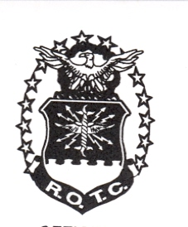

 4cadet female head gear

Note 4

Note 2

Note 1

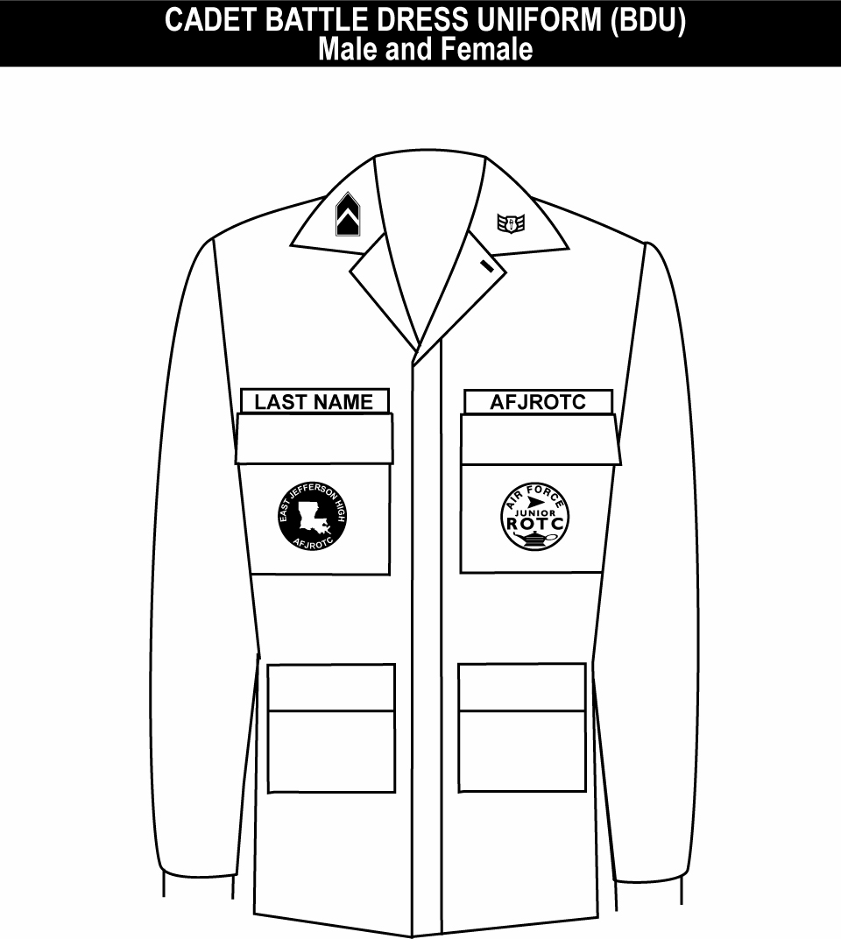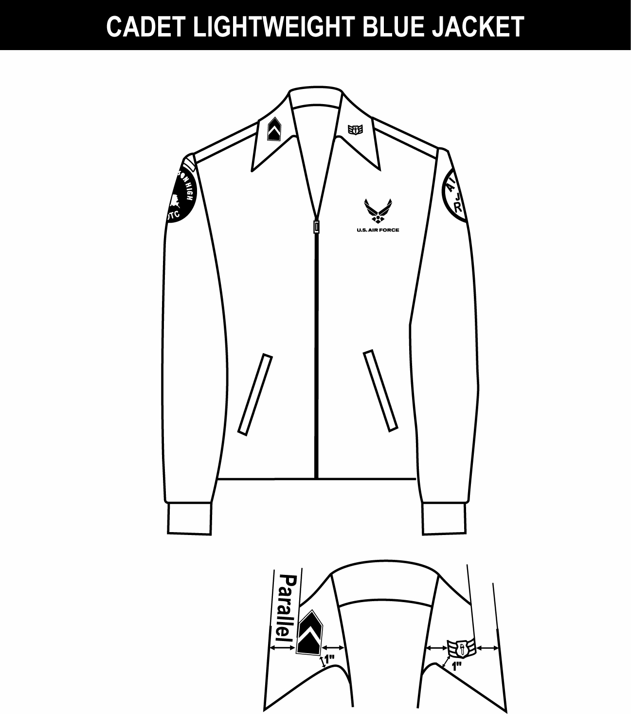

Note 4

Note 1

Note 2

Note 3

1. Unit patch worn on right pocket and centered.

2. Tapes grounded and centered on pockets.

3. Grade insignia (officer or enlisted) is worn on both left and right collars, centered on collar and parallel with bottom of collar. Airman Basic have no collar insignia.

4. AFJROTC patch worn on left pocket and centered.

Note 1

Outer edge

Outer edge

LIGHTWEIGHT BLUE JACKET

COLLAR INSIGNIA

Note 5

Note 8

Note 7

Note 6

Note 4

Note 3

Note 2

 7CADETMALE1620SERVICEDRESS 10-05 9cadetFEM1620SERvicedress v4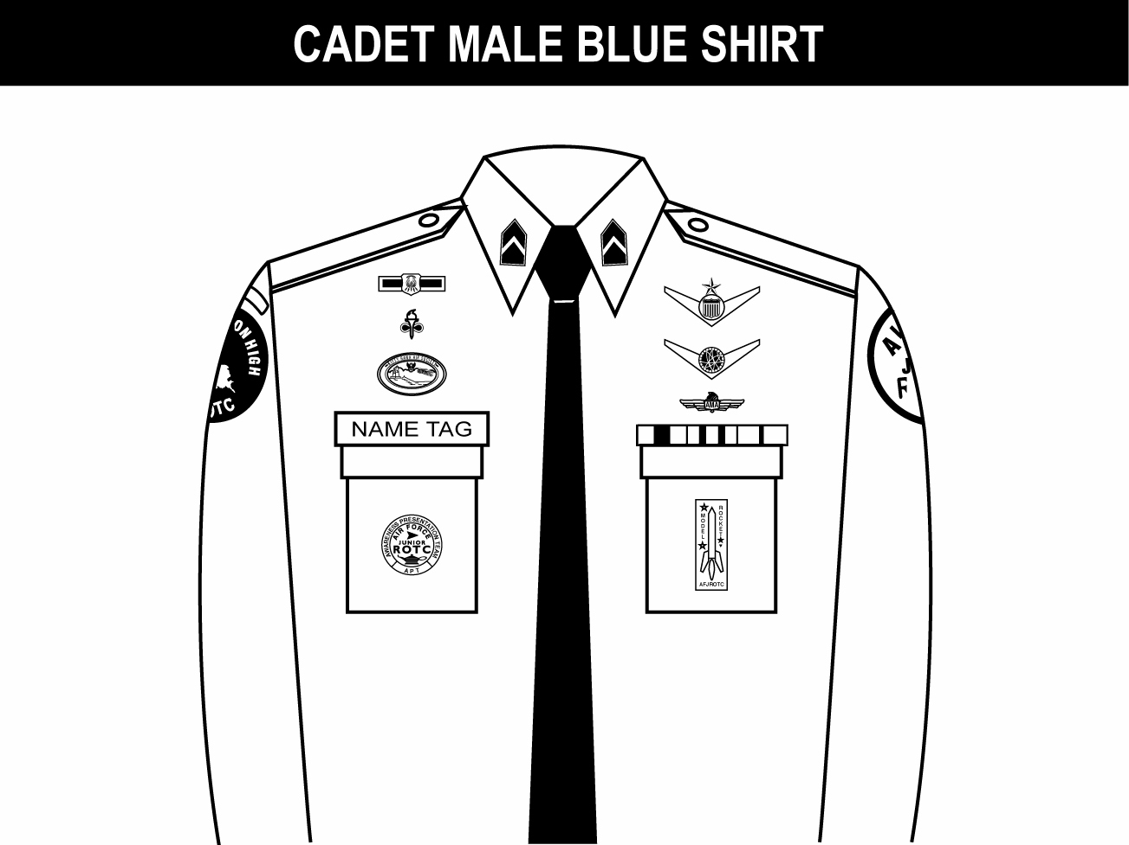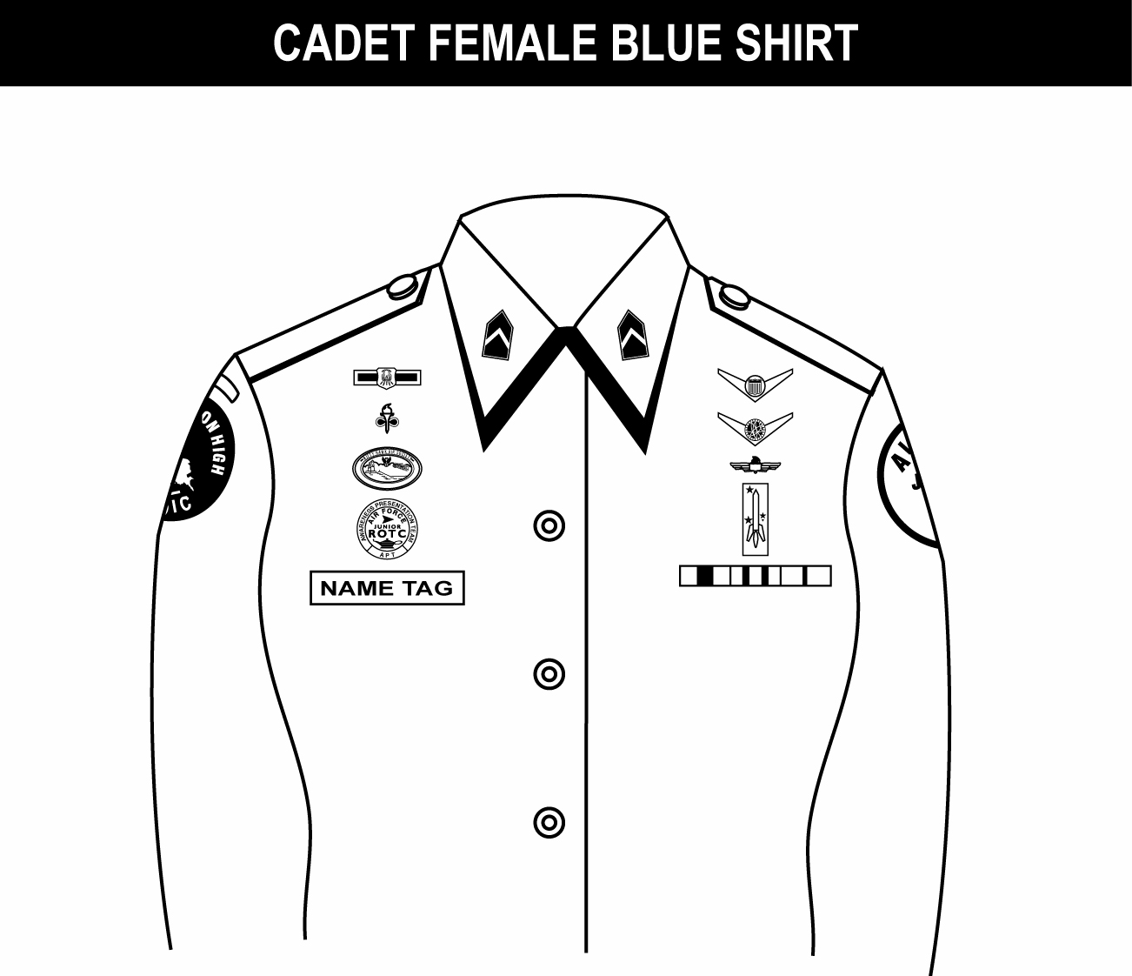

1. (Officers only) When placing rank on epaulet instead of collar, use standard size metal rank, center on epaulet 5/8 in from shoulder seam.

2. Shoulder tabs are centered between unit patch and shoulder seam. If no patch, then 1” below shoulder seam.

3. Unit patch on right sleeve ½ to 1 inch below shoulder seam and centered.

4. Grade insignia (officer and enlisted) is worn on both left and right collar. Airman Basic have no collar insignia.

5. Optional item: center vertically between the shoulder seam and where the underarm side seam joins the armhole sleeve and center horizontally between the center zipper and the sleeve armhole seam.

6. AFJROTC patch on left sleeve ½ to 1 inch below shoulder seam and centered.

7. Jacket will be closed to at least the halfway point.

8. Center insignia horizontally on collar. Place 1 inch from bottom of collar and parallel to the outer edge of the collar.

1. Awareness Presentation Team (APT) badge: Center on welt pocket 3 inches below the top.

2. Name tag: Center between arm seam and lapel with bottom edge parallel to top of welt pocket

3. Kitty Hawk Badge: see note 15.

4. Unit patch: Placed ½ to 1 inch below shoulder seam and centered.

5. Shoulder tabs: Center between unit patch and shoulder seam. If no patch, then 1 inch below shoulder seam.

6. Aerospace Education Foundation (AEF) Badge: see note 15.

7. Distinguished Cadet Badge: see note 15.

8. Grade insignia (officer or enlisted) worn on both lapels. Place insignia halfway up the seam, resting on but not over it. Bottom of insignia is horizontal with the ground. *(The lapel insignia (eagles non-chrome) will no longer be worn on the lapels by Airmen Basics.)

9. AFJROTC Patch: Placed ½ to 1 inch below shoulder seam, and centered.

10. Flight Solo or Flight Certificate Badge: see note 15.

11. Ground School Badge: see note 15.

12. Ribbons: Center, on but not over edge of pocket. Wear 3 or 4 in a row. Wear all or some.

13. Academy of Model Aeronautic Wings: worn 1 inch below pocket.

14. Model Rocketry Badge: worn 2 inches below AMA Wings or 3 inches below pocket if no AMA Wings are worn.

15. First badge placed ½ inch above name tag or ribbons and is centered horizontally. Additional badges placed ½ inch above previous badge.

Note: Cadets may wear the rank on both coat and shirt at the same time or only on the coat. The cadets must be in proper uniform at all times. If they have the coat on, the rank insignia must be on the coat. If they remove the coat, the rank must be on the shirt.

Note 14

Note 13

Note 12

Note 11

Note 10

Note 9

Note 8

Note 7

Note 6

Note 5

Note 4

Note 3

Note 2

Note 1

Note 1

Note: Cadets may wear the rank on both coat and shirt at the same time or only on the coat. The cadets must be in proper uniform at all times. If they have the coat on, the rank insignia must be on the coat. If they remove the coat, the rank must be on the shirt.

1. Name tag: authorized for wear and is to be centered on right side, even with to 1 1/2 inches higher or lower than the first exposed button.

2. Awareness Presentation Team Badge: see note 15.

3. Unit patch: center ½ to 1 inch below shoulder seam.

4. Shoulder tab: centered between unit patch and shoulder seam. If no patch, then 1 inch below shoulder seam.

5. Kitty Hawk Badge: see note 15.

6. Aerospace Education Foundation (AEF) Badge: see note 15.

7. Distinguished Cadet Badge: see note 15.

8. Grade insignia (officer or enlisted) worn on both lapels. Place insignia halfway up the seam, resting on but not over it. Bottom of insignia is horizontal with the ground. *(The lapel insignia (eagles non-chrome) will no longer be worn on the lapels by Airmen Basics.)

9. Flight Solo or Flight Certificate Badge: see note 15.

10. Ground School Badge: see note 15.

11. AFJROTC Patch: center ½ to 1 inch below shoulder seam.

12. Academy of Model Aeronautic (AMA) Wings: see note 15.

13. Model Rocketry Badge: see note 15.

14. Ribbons: center ribbons resting on but not over edge of welt pocket. Wear 3 or 4 in a row. Wear all or some.

15. First badge placed ½ inch above name tag or ribbons (whichever is appropriate) and is centered horizontally. Additional badges placed ½ inch above previous badge.

Note 14

Note 13

Note 12

Note 11

Note 10

Note 9

Note 8

Note 7

Note 6

Note 5

Note 4

Note 3

Note 2

Note 1

1. Awareness Presentation Team (APT) and Model Rocketry Badge are centered on the pockets on the appropriate sides as displayed above.

2. Name tag: authorized for wear and is to be grounded and centered over wearer’s right pocket.

3. Unit patch: center ½ to 1 inch below shoulder seam.

4. Shoulder tab: center between unit patch and shoulder seam. If no patch, then place 1 inch below shoulder seam.

5. Kitty Hawk Badge: see note 15.

6. Aerospace Education Foundation (AEF) Badge: see note 15.

7. Distinguished Cadet Badge: see note 15.

8. Grade insignia (officer or enlisted) worn on both left and right collar, centered side to side and top to bottom. Enlisted rank’s bottom point of torch points toward the point of the collar. Officer top point of rank aligned with point of collar. Airman Basic have no insignia of any kind on the collar.

9. (Officers only) When using officer cloth rank on epaulets versus miniature metal rank on collar, place as close as possible to shoulder seam.

10. Flight Solo or Flight Certificate Badge: see note 15.

11. Ground School Badge: see note 15.

12. Academy of Model Aeronautic (AMA) Wings: see note 15.

13. AFJROTC Patch: center ½ to 1 inch below shoulder seam.

14. Ribbons: ground and center on pocket.

15. First badge placed ½ inch above name tag or ribbons and is centered horizontally. Additional badges placed ½ inch above previous badge.

Note 14

Note 13

Note 12

Note 11

Note 10

Note 9

Note 8

Note 7

Note 6

Note 5

Note 4

Note 3

Note 2

Note 1

1. Name tag: authorized for wear and is to be centered on right side, even with to 1 1/2 inches higher or lower than the first exposed button.

2. Awareness Presentation Team Badge: see note 16.

3. Unit patch: center ½ to 1 inch below shoulder seam.

4. Shoulder tab: centered between unit patch and shoulder seam. If no patch, then 1 inch below shoulder seam.

5. Kitty Hawk Badge: see note 16.

6. Aerospace Education Foundation (AEF) Badge: see note 16.

7. Distinguished Cadet Badge: see note 16.

8. Grade insignia (officer or enlisted) worn on both left and right collar, centered side to side and top to bottom. Enlisted rank’s bottom point of torch points toward the point of the collar. Officer top point of rank aligned with point of collar. Airman Basic have no insignia of any kind on the collar.

9. (Officers only) When using officer cloth rank on epaulets versus miniature metal rank on collar, place as close as possible to shoulder seam.

10. Flight Solo or Flight Certificate Badge: see note 16.

11. Ground School Badge: see note 16.

12. Academy of Model Aeronautic (AMA) Wings: see note 16.

13. AFJROTC Patch: center ½ to 1 inch below shoulder seam.

14. Model Rocketry Badge: see note 16.

15. Ribbons: Center, parallel with ground. Align with bottom of name tag. Or, if no name tag, align bottom of ribbons even with to 1 ½ inches higher or lower than the first exposed button.

16. First badge placed ½ inch above name tag or ribbons (whichever is appropriate) and is centered horizontally. Additional badges placed ½ inch above previous badge.

Note 15

Note 13

Note 14

Note 12

Note 11

Note 10

Note 9

Note 8

Note 7

Note 6

Note 5

Note 4

Note 3

Note 2

Note 1

**Uniform Inspections**

Uniform inspections are graded and count toward final grades. As a minimum, uniform inspections will be conducted on the designated uniform day. There are two types of inspections: formal and informal. A formal inspection is conducted in formation. An informal inspection may take place in the classroom with cadets at their seats. They will either be completed by the SASI/ASI’S or the cadet leadership staff. A detailed record will be kept of all inspections.

If a cadet is not in uniform on uniform or inspection day they receive a zero grade (0) for the inspection and a written excuse or explanation directly from a parent or guardian must be presented to the SASI/ASI’S.

Most common excuses and explanation:

1. “I forgot.” (POOREST EXCUSE) Response: You must learn responsibility for your actions and must plan ahead in order to meet your obligations.
2. “My parents forgot.” (NEXT POOREST EXCUSE) Response: Do not depend on anyone else to prepare your uniform. It is your responsibility. We don’t give grades to your parents; we give them to you.
3. “It’s in the cleaners.” (POOR EXCUSE) Response: Uniform day is once a week, therefore, after wearing, inspect it and ensure it is ready for the following week. If it needs cleaning or washing (shirt only), take care of it immediately so it will be ready for inspection day.
4. “The trousers or pants are torn.” Or, “The zipper is broke.” (Costly in terms of grade and money). (ANOTHER POOR ESCUSE) Response: Prior to the inspection (written excuse) advise an instructor when this happens. If it just happened, perhaps it was caused by last minute rushing or by not taking proper care of the uniform.
5. “No excuse, Sir.” (HONEST) Response: Take the poor results of your performance and most of all “care more.”

**Cadet Inspection Checklist** (as of 8 September, 2011)   
 NJ-20003rd Cadet Corps   
   
Cadet:_________________________________ Flight:_________________

C/Rank, Last Name

|  |  |  |  |  |  |  |
| --- | --- | --- | --- | --- | --- | --- |
| **Date** |  |  |  |  |  |  |
| **Possible Uniform Discrepancies (Dress Blues)** |  |  |  |  |  |  |
| Excessive Lint/Dirt on Uniform -10 pts |  |  |  |  |  |  |
| Uniform Pressed/ Ironed -10 pts |  |  |  |  |  |  |
| Missing Patch(s) - 5pts (per patch) |  |  |  |  |  |  |
| Cables (thread / strings) -2 pt (per cable) |  |  |  |  |  |  |
| Hair is not within regulations -30 pts |  |  |  |  |  |  |
| Shave -30 pts |  |  |  |  |  |  |
| Unauthorized Jewelry -10 pts (per item) |  |  |  |  |  |  |
| Gig Line -3 pts |  |  |  |  |  |  |
| Belt/Belt Buckle -3 pts |  |  |  |  |  |  |
| Rank Insignia -5 (per rank) |  |  |  |  |  |  |
| Ribbons/Metals/Badges -10 pt |  |  |  |  |  |  |
| Buttons (missing buttons or unbutton) -2 pts (per button) |  |  |  |  |  |  |
| Tie/Tie Tab -15 pts |  |  |  |  |  |  |
| Trousers/Slacks/Skirt -5 pts |  |  |  |  |  |  |
| Socks (must be black) -15 pts |  |  |  |  |  |  |
| Shoes (Not Shined, dirty, etc.) -10 pts |  |  |  |  |  |  |
| Civilian shoes/ sneakers -30 pts |  |  |  |  |  |  |
| Military Bearing -10 pts (per infraction) |  |  |  |  |  |  |
| Responses to questions -5 pt (per question) |  |  |  |  |  |  |
| Colored T-Shirts (under uniform) -10 pts |  |  |  |  |  |  |
| Conduct (Conduct unbecoming an AFJROTC Cadet)  -30 pts to -100 pts |  |  |  |  |  |  |
| PDA in Uniform -50 to 100 pts. |  |  |  |  |  |  |
| Changing out of Uniform -100 pts. |  |  |  |  |  |  |
| Body Odor/ Personal Cleanliness -10 pts. |  |  |  |  |  |  |
| **Possible Uniform Discrepancies (BDU’S)** |  |  |  |  |  |  |
| Excessive Lint/Dirt on Uniform -5 to -10 Pts |  |  |  |  |  |  |
| Cables -1pt (per cable) |  |  |  |  |  |  |
| Hair is not within regulations -30 pts |  |  |  |  |  |  |
| Shave -30pts |  |  |  |  |  |  |
| Jewelry -10 pts (per item) |  |  |  |  |  |  |
| Belt/Belt Buckle -3 pts |  |  |  |  |  |  |
| Rank Insignia -10 (per rank) |  |  |  |  |  |  |
| Buttons -2 pts (per button) |  |  |  |  |  |  |
| Boots not shinned -10 pts |  |  |  |  |  |  |
| Military Bearing -10 pts (per infraction) |  |  |  |  |  |  |
| Responses to questions -5 pts |  |  |  |  |  |  |
| T-Shirts (must be black or brown) -10 pts |  |  |  |  |  |  |
|  |  |  |  |  |  |  |
| Grade |  |  |  |  |  |  |
| Inspector’s Signature |  |  |  |  |  |  |
| Cadet Signature |  |  |  |  |  |  |

**Unauthorized Wear of the Uniform**

The AFJROTC uniform will be worn proudly and honorably. This is the same uniform worn by men and women an active duty throughout the world defending the ideals that make our country the greatest nation on earth. Improperly or inappropriately wearing the uniform brings discredit on the United States, the school and our cadet corps.

Following are some examples of unauthorized uniform wear:

1. No item of the Air Force uniform will be worn by anyone except members of the AFJROTC unit. Federal law prohibits “wear without authority,” and states “any person within the jurisdiction of the United States who wears a uniform or a distinctive part of the uniform of the US Armed Services without authority is subject to penalties prescribes in Section 18, US Code 702.”
2. Cadets are not permitted to wear the uniform while participating in student demonstrations either as participants or in the capacity of police or guards.
3. Cadets are not permitted to wear the uniform or any uniform accessories except to and from official AFJROTC activities. Cadets violating this policy could be considered for removal from the AFJROTC program.
4. Public display of affection or hand holding while in uniform is prohibited.
5. Wearing headsets or ear pieces, such as the type used with portable radios or tape/CD players, is prohibited while in uniform.

**Chapter 6: Promotion Policy and Procedures**

**Purpose:**  The purpose OF cadet promotions is to reward and recognize cadets who consistently meet or exceed standards of behavior, appearance, leadership, and academic performance. Eligible cadets maintain a positive attitude, consistently contribute to the success of the unit, and demonstrate the potential for increased responsibility.

**Categories of cadet rank:** There are two categories of cadet rank: “permanent” and “temporary.” All cadets are assigned a permanent rank based on the number of years of AFJROTC satisfactorily completed as follows (See Attachment 2):

AS-1 Cadet Airman Basic (AB)

AS-2 Cadet Airman (Amn)

AS-3 Cadet Airman First Class (A1C)

AS-4 Cadet Senior Airman (SrA)

The SASI/ASI’S may promote cadets to “temporary” ranks including senior enlisted and officer positions based on the level of responsibility and positions of leadership. Officer positions will normally be limited to capable cadets in their 3rd and 4th years. Failure to do job responsibilities or conduct that is unbecoming of a cadet may result in removal of position, demotion of rank and, if varying the severity of the actions, result in disciplinary action by the school.

**Primary standards/criteria for promotion:** The minimum criteria and qualities considered before making a decision to recommend a cadet for temporary rank promotions are based on our unit’s core values as follows:

1. Does cadet meet/exceed grooming standards and do they wear the uniform properly?
2. Does cadet have a satisfactory attendance record? Does cadet have unexcused absences? Has cadet cut classes? Is cadet performing responsibly, professionally, and to his/her potential in all classes?
3. Is cadet participating in classroom, co-curricular, and extra-curricular activities?
4. Does cadet show proper respect for all teachers, fellow cadets, and other students?
5. Does cadet have positive attitude toward AFJROTC program including academics?
6. Is cadet capable of added responsibility without his/her academic standing suffering?
7. Is cadet willing to take on added responsibility
8. Is cadet well versed in drill and ceremony procedures?

**Rank Structure**

**Airmen Junior NCO**

C/ Airman Basic C/ Staff Sergeant

C/ Airman C/ Technical Sergeant

C/ Airman First Class

C/ Senior Airman

**Senior NCO Officers**

C/ Master Sergeant C/ 2nd Lieutenant

C/ Senior Master Sergeant C/ 1st Lieutenant

C/ Chief Master Sergeant C/ Captain

C/ Major

C/ Lieutenant Colonel

C/ Colonel

**Specific Promotion Guidelines**

1. **Promotion to Airman**
   1. Overall Grade – Passing
   2. ROTC Grade – 75 or above
   3. Uniform Grade – Passing
   4. No 3 to 7s or suspensions
   5. Held previous rank for previous marking period
2. **Promotion to Junior NCO**
   1. Overall Grade – Passing
   2. ROTC Grade – 80 or above
   3. Uniform Grade – Passing
   4. No 3 to 7s or suspensions
   5. Held previous rank for previous marking period
   6. Pass JNCO promotion test with – 85* or above
3. **Promotion to Senior NCO**
   1. Overall Grade – Passing
   2. ROTC Grade – 90 or above
   3. Uniform Grade – Passing
   4. No 3 to 7s or suspensions
   5. Teacher recommendation
   6. Be at least a Senior Airman
   7. Pass SNCO promotion test with – 85* or above
4. **Promotion to Officer**
   1. Overall Grade – Passing
   2. ROTC Grade – 90 or above
   3. Uniform Grade – Passing
   4. No 3 to 7s or suspensions
   5. Teacher recommendation
   6. Pass Officer promotion test with – 85* or above

*When a cadet has passed a test to become JNCO, SNCO, or Officer, they will be promoted automatically to higher ranks in that level based on the other guidelines.

**Disenrollment Criteria:**

1. Failure to maintain acceptable standards (including uniform wear and grooming)
2. Inaptitude or indifference to training
3. Disciplinary reasons
4. Any other reason deemed appropriate by the principal and the AFJROTC Instructors

**\*** If the offending cadet has had a history of discipline and/or punishment they will face possible disenrollment depending on a case by case basis

**Chapter 7: Organization**

**Command and Staff Functions**

Our AFJROTC unit will be organized in command and staff functions to efficiently carry out the mission. A duty description will be developed for each position. Cadets who display leadership potential, a team attitude, and make significant contributions to the success of the cadet corps will be chosen for leadership staff positions.

1. **Cadet Leadership:** Cadet Commanders (CC) will be appointed at the wing, group, squadron, and flight levels. A Group Commander (GC) will be in charge of the NJ-20003rd Cadet Corps and will be assisted by a Vice Group Commander (CV), Executive Officer (EO) Command Chief Master Sergeant (CCMS), Inspector General (IG), Kitty Hawk Air Society Commander (KHAS) Squadron Commanders (SC), Squadron First Sergeants (SFS), Flight Commanders (FC), and Flight Sergeants (FS).

2. **Staff Positions: S**taff positions are established to perform specific functions managing the unit. These positions are titled and are similar to those found in the Air Force as well as in the civilian sector. Following are the staff positions that will be needed to effectively run the corps.

* Logistics
* Personnel
* Technology
* Academics
* Public Affairs
* Operations
* Recruiting & Retention
* Community Service
* Drill & Ceremonies

1. **Unit Leadership Staff:** Each staff member is accountable for their area of responsibility. They must have complete knowledge of their duties, oversee the work of their own staff carrying out those duties, and become familiar with duties and responsibilities of other unit staff positions.
2. **Staff Meetings:** staff meetings will be held every Wednesday, when in school, to plan and organize unit activities/projects.
3. **Unit Cadets:** All unit members will be expected to get involved with planning, organizing, and participating in unit events. They must understand how the unit is organized and provide support to the cadet leadership and other cadets.

**Start of Class Reporting Procedures**

The following reporting procedure will be used at the beginning of every class:

* 1. Immediately after the late bell rings, the Flight Sergeant (FLT SGT) (or designee) will command: “FLIGHT, FALL IN.”
  2. Everyone stands next to their seats at the position of attention. When the flight is formed, the Flight Sergeant will command “PARADE REST.”
  3. The Flight Sergeant (or designee) will face the Flight Commander (FLT CC), salute and state, “SIR (OR MA’AM) THE FLIGHT IS FORMED.”
  4. The FLT CC will return the salute and command, “RECEIVE THE REPORT.”
  5. The 1st Element Leader will command, “FIRST ELEMENT, ATTENTION,” salute the FLT SGT and report, “SGT, ALL PRESENT AND ACCOUNTED FOR, or SGT, CADET __________, UNACCOUNTED FOR.”
  6. FLT SGT will return the element leader’s salute.
  7. ELEMENT LEADER will command “FIRST ELEMENT, PARADE REST.”
  8. All remaining elements will report in the same manner.
  9. Once reporting is completed, the FLT SGT will command, “FLIGHT, ATTENTION,” face the FLT CC and report attendance.
  10. FLT CC returns FLT SGT salute, faces and salutes the SASI/ASI and state, “SIR, THE FLIGHT IS READY FOR INSTRUCTION.”
  11. SASI/ASI will make announcements, and then command “SEATS.”

**Chapter 6: Miscellaneous**

**Special Activities and Projects**

**Color Guard:** Cadets are eligible to try out for the unit’s color guard team. Those who qualify will have the distinct privilege of carrying the United States, New Jersey, Air Force, and school flags at school functions, parades, ceremonies, and competitions. Color Guard members’ train and practice after school to learn the proper use and care of the flag. Color guard members must excel in drill, be self-disciplined, and display the highest standards of military bearing and personal appearance.

**Drill Team:** Cadets are eligible to try out for the unit’s drill team. The drill team specializes in precision drill and participates in local parades, ceremonies, drill demonstrations, and competitions. Drill team members train and practice after school to learn proper drill techniques. Drill team members must excel in drill, be self-disciplined, and display the highest standards of military bearing and personal appearance.

**Model Rocketry Club:** Cadets interested in the science of aerospace and rockets are all encouraged to join the Model Rocketry Club. Cadets in the club will learn the basics of rocketry and will build and launch their own rockets.

**Unit’s Newsletter:** The Public Affairs Officer and staff write and produce a newsletter that is designed to inform the school, unit members, and the public of AFJROTC happenings, up and coming events, successes, etc. Cadets with an interest or talent in art or journalism are encouraged to serve on the newsletter staff.

**Field Trips:** Aerospace classes take part in field trips appropriate to their level in the AFJROTC program. These are co-curricular field trips taken to complement course study and organizational functions. Field trips may include visits to Dover AFB, McGuire AFB, Washington D.C., Atlantic City ANGB, and the Gettysburg Battlefield.

**Community Involvement:** Cadets have the opportunity to become involved in worthwhile programs benefiting the school and local community.

**Fundraisers:** AFJROTC cadets will sponsor fund raising events each year to subsidize payment for co-curricular and extracurricular activities. Each cadet will be expected to participate in unit-sponsored fund raising activities.

**Social Events:** Plans will be made to hold social events such as the Dining Out/Military Ball, awards and recognition ceremony, and end of year picnic and field day. These events strengthen the bond between cadets including the cooperative effort and teamwork of our corps.

**Patriotic/Air Force Songs**

**The Star Spangled Banner**

*O say, can you see by the dawn’s early light,*

*What so proudly we hailed at the twilight’s last gleaming?*

*Whose broad strips and bright stars through the perilous fight,*

*O’er the ramparts we watched were so gallantly streaming;*

*And the rockets red glare, the bombs bursting in air,*

*Gave proof through the night that our flag was still there.*

*O say does that star spangled banner yet wave,*

*O’er the land of the free and the home of the brave.*

**America The Beautiful**

*O Beautiful for spacious skies,*

*For amber waves of grain*

*For Purple mountain majesties*

*Above the fruited plains!*

*America! America!*

*God shed His grace on thee*

*And crown the good with brotherhood*

*From sea to shining sea!*

**The Air Force Song**

*Off we go into the wild blue yonder*

*Climbing high in to the sun;*

*Here they come zooming to meet our thunder,*

*At’em boys, giv’er the gun!*

*Down we dive, spouting our flames from under,*

*Off with one helluva roar!*

*We live in fame or go down in flame,*

*Hey, nothing can stop the U.S. Air Force!*

**The Phonetic Alphabet**

**A**lpha **N**ovember

**B**ravo **O**scar

**C**harlie **P**apa

**D**elta **Q**uebec

**E**cho **R**omeo

**F**oxtrot **S**ierra

**G**ulf **T**ango

**H**otel **U**niform

**I**ndia **V**ictor

**J**uliett **W**hiskey

**K**ilo **X**-ray

**L**ima **Y**ankee

**M**ike **Z**ulu

**Military Time**

Military time is the standard used by the U.S Armed Forces as well as ROTC and JROTC. There are four main points for military time, they are as follows:

* Military time has no colon to separate hours and minutes
* Hours are numbered one through twenty-four instead of using A.M and P.M.
* Has no designated O’ clock
* A zero precedes the hours 1 through 9

0100 Zero One Hundred 1:00A.M

0200 Zero Two Hundred 2:00A.M

0300 Zero Three Hundred 3:00A.M

0400 Zero Four Hundred 4:00A.M

0500 Zero Five Hundred 5:00A.M

0600 Zero Six Hundred 6:00A.M

0700 Zero Seven Hundred 7:00A.M

0800 Zero Eight Hundred 8:00A.M

0900 Zero Nine Hundred 9:00A.M

1000 Ten Hundred 10:00A.M

1100 Eleven Hundred 11:00A.M

1200 Twelve Hundred 12:00A.M

1300 Thirteen Hundred 1:00P.M

1400 Fourteen Hundred 2:00P.M

1500 Fifteen Hundred 3:00P.M

1600 Sixteen Hundred 4:00P.M

1700 Seventeen Hundred 5:00P.M

1800 Eighteen Hundred 6:00P.M

1900 Nineteen Hundred 7:00P.M

2000 Twenty Hundred 8:00P.M

2100 Twenty-One Hundred 9:00P.M

2200 Twenty-Two Hundred 10:00P.M

2300 Twenty-Three Hundred 11:00P.M

2400 Twenty-Four Hundred 12:00 Midnight

0005 Zero-Zero-Zero Five 12:05 A.M